# CS 255 System Design Document Template

This template lays out all the different sections that you need to complete for Project Two. Each section has guidance to prompt your thinking. You will need to continually reference the interview transcript as you work to make sure that you are addressing your client’s needs. There is no required length for the final document. Instead the goal is to complete each section based on what your client’s needs are. Remove this note when you are finished, and replace all bracketed text with the relevant information.

## UML Diagrams

### UML Use Case Diagram

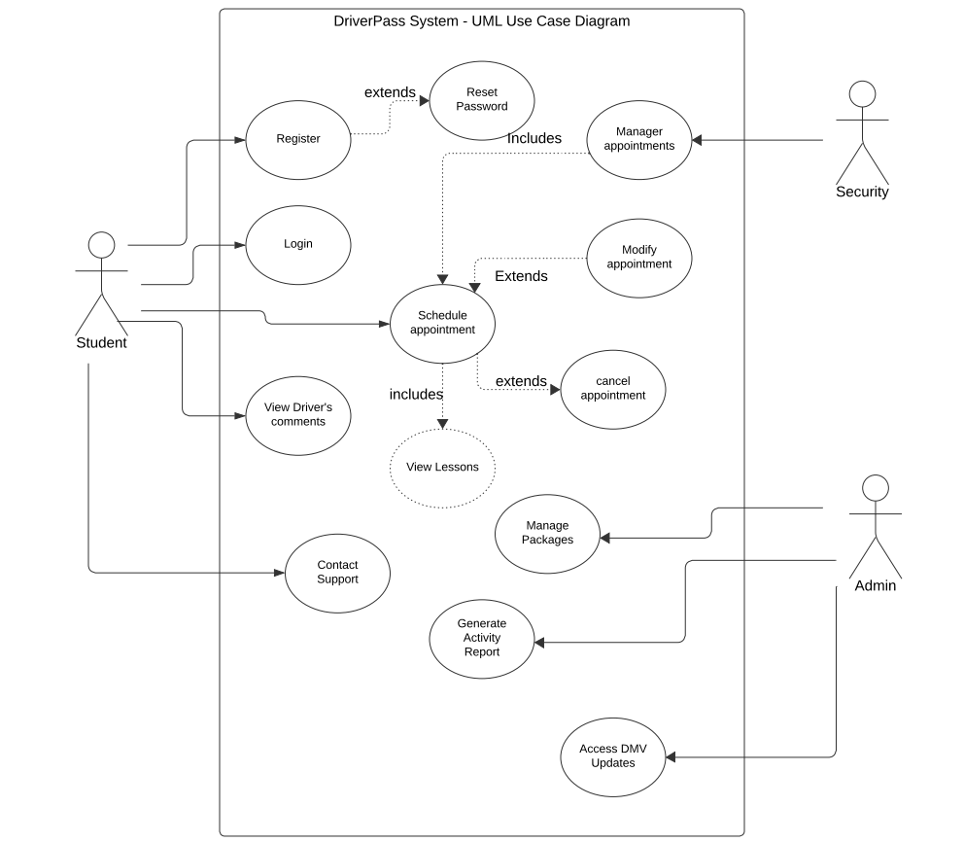

### UML Activity Diagrams

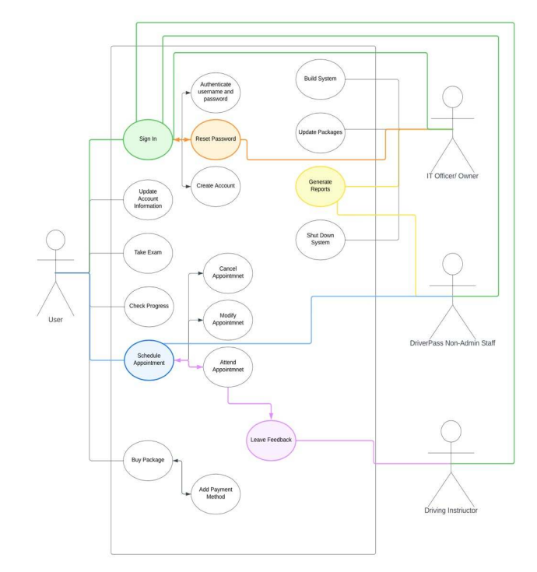

### UML Sequence Diagram

### UML Class Diagram

## Technical Requirements

*For the hardware you are required to have a dedicated server, reliable connection to the internet, decent storage for the data from the website and database, a mobile or computer device to access the website, a firewall to safequard the ports of the website.*

*The software requirements would be the utilization of Windows servers for the stability. A deployment of an SQL Server for the database, integration of the backup of the database and website in case of emergencies, and the inclusion of security to protect from malware.*

*Geographic considerations is also required which would ensure website accessibility in the USA, secure the website and database in a data center, and finally placing the server in a central location for accessibility and excellent performance.*